Htno:2403A51349
Batch:14

Assignment 4.3
Task Description#1
- Zero-shot: Prompt AI to write a function that checks whether a given year is a leap year.

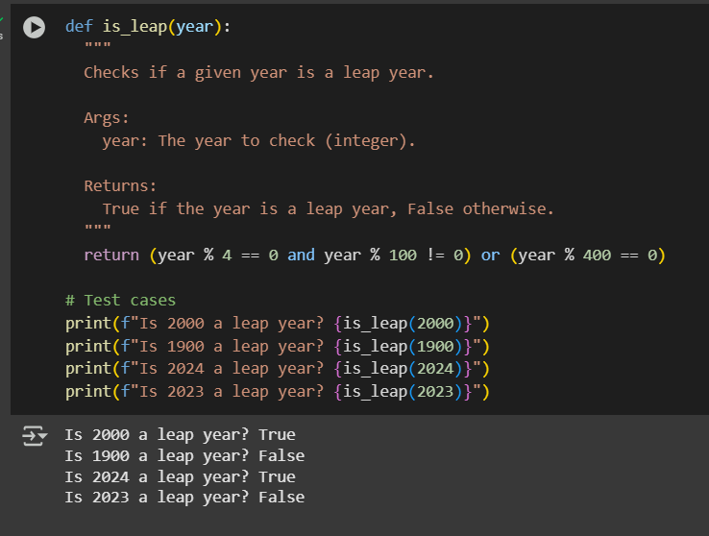
Output:


Task Description#2
- One-shot: Give one input-output example to guide AI in writing a function that converts centimeters to inches.

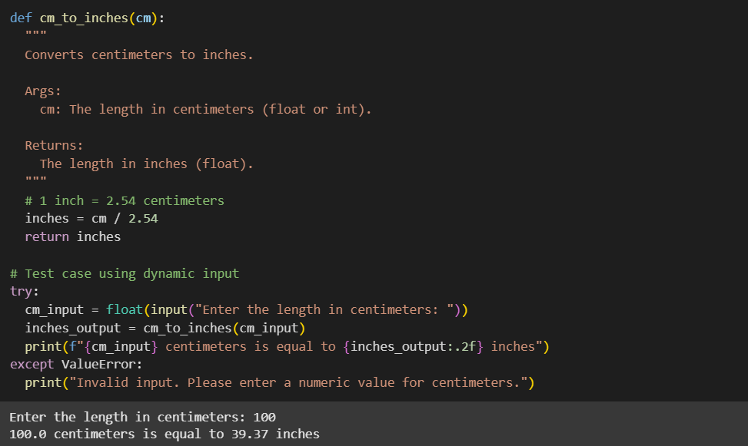

Output:



Task Description#3
- Few-shot: Provide 2–3 examples to generate a function that formats full names as “Last, First”.

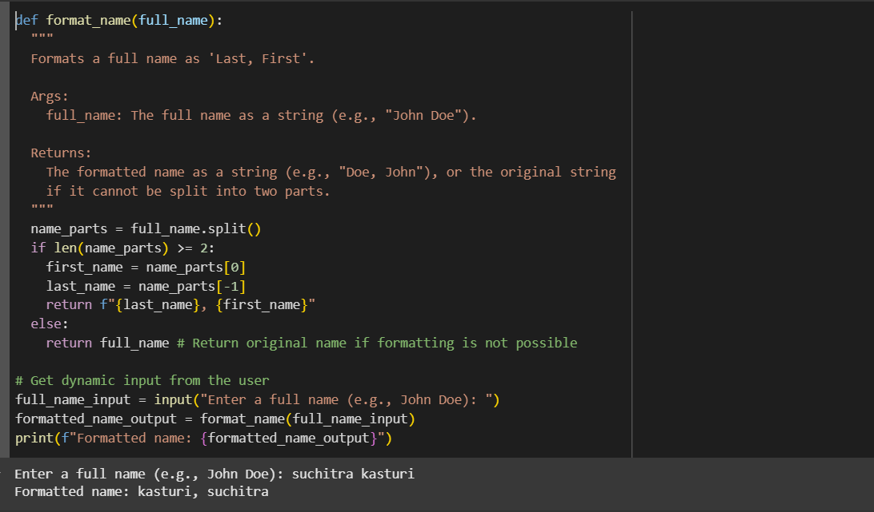

Output:



Task Description#4
- Compare zero-shot and few-shot prompts for writing a function that counts the number of vowels in a string.

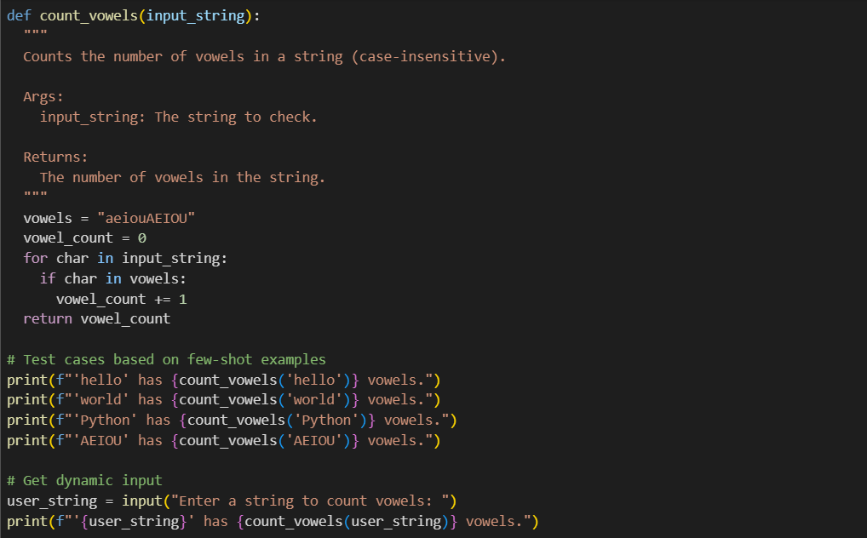

Output:

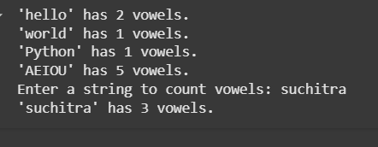

Task Description#5
Use few-shot prompting to generate a function that reads a .txt file and returns the number of lines.

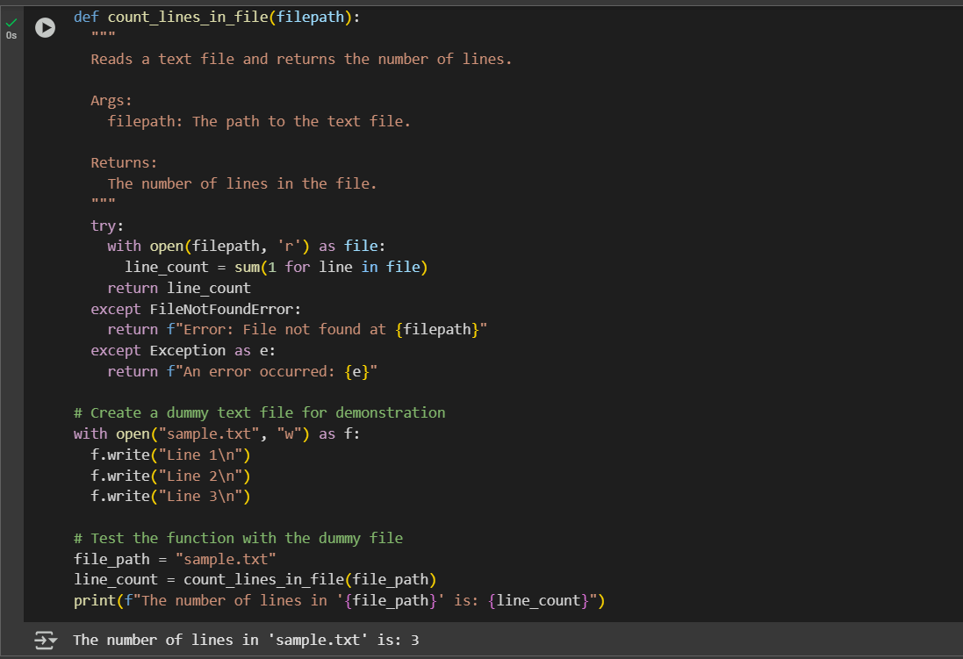
Output:



